My JSON Research

**JSON:**stands for JavaScript Object Notation that  is a language independent text format which is fast and easy to understand.

**"var JSONObjectName = { "name ":"amit", "age":23};**will create an Object with attribute **name** which contains value in String and **age**with numeric value.

Example.

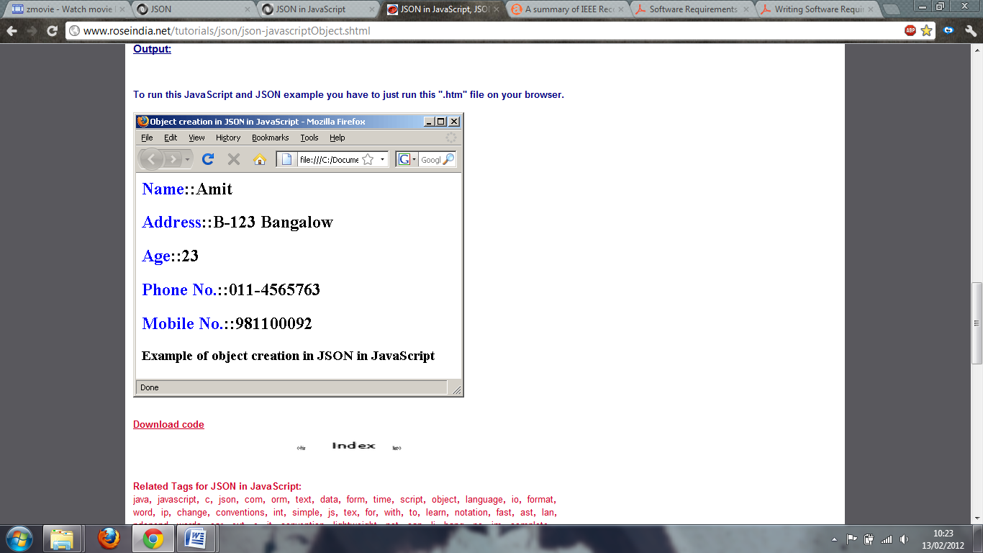<html>  
<head>  
<title>  
 Object creation in JSON in JavaScript  
</title>  
<script language="javascript" >  
var JSONObject = {  "name" : "Amit",  
  "address"  : "B-123 Bangalow",  
  "age"  : 23,   
   "phone"   : "011-4565763",  
   "MobileNo"  : 0981100092  
  };  
document.write("<h2><font color='blue'>Name</font>::"  
   +JSONObject.name+"</h2>");    
document.write("<h2><font color='blue'>Address</font>::"  
   +JSONObject.address+"</h2>");    
document.write("<h2><font color='blue'>Age</font>::"  
   +JSONObject.age+"</h2>");    
document.write("<h2><font color='blue'>Phone No.</font>::"  
   +JSONObject.phone+"</h2>");    
document.write("<h2><font color='blue'>Mobile No.</font>::"  
   +JSONObject.MobileNo+"</h2>");    
</script>  
</head>  
<body>  
<h3>Example of object creation in JSON in JavaScript</h3>  
</body>  
</html>